
American International University-Bangladesh (AIUB)
Department of Computer Science
Faculty of Science &Technology (FST)
Spring 24-25
Section: C
Software Quality and Testing
AutoCart: Intelligent E-Commerce with Predictive Auto-Refill & Smart Bundling
Report Submitted By

SN | Student Name | Student ID
1 | MD. SHOHANUR RAHMAN SHOHAN | 22-46013-1
2 | FARJANA YESMIN OPI | 22-47018-1
3 | MD. ABU TOWSIF | 22-47019-1
4 | A. F. M. RAFIUL HASSAN | 22-47048-1

Checked By Industry Personnel (Optional)

Name:

Designation:

Company:

Sign:

Date:

Software Test Plan

for

AutoCart: Intelligent E-Commerce with Predictive Auto-Refill & Smart Bundling
Version 1.0 approved
Prepared By
1. MD. SHOHANUR RAHMAN SHOHAN
2. FARJANA YESMIN OPI
3. MD. ABU TOWSIF
4. A. F. M. RAFIUL HASSAN
Date : 26-06-2025

Table of Contents
Revision History 3
1. TEST PLAN IDENTIFIER: TP-AutoCart-2025-001 4
2. REFERENCES 4
3. INTRODUCTION 5
Background to the Problem 5
Solution to the Problem 5
4. REQUEIREMNT SPECIFICATION 6
4.1 System Features 6
4.2 System Quality Attributes 9
4.3 System Interface…………………………………………………………………………………11
4.4 Project Requirements……………………………………………………………………………18
5. FEATURES NOT TO BE TESTED………………………………………………………….20
6. TESTING APPROACH………………………………………………………………………20
6.1 Testing Levels…………………………………………………………………………….……..20
6.2 Testing Tools…………………………………………………………………………………….21
6.3 Meetings………………………………………………………………………………………….21
7. TEST CASES/TEST ITEMS…………………………………………………………………23
8. ITEM PASS/FAIL CRITERIA……………………………………………………………….38
9. TEST DELIVERABLES……………………………………………………………………..38
10. STAFFING AND TRAINNING NEEDS……………………………………………………39
11. RESPONSIBILITIES………………………………………………………………………………40
12. TESTING SCHEDULE……………………………………………………………………...41
13. PLANNING RISKS AND CONTINGENCIES……………………………………………..41
14. APROVALS…………………………………………………………………………………42

Revision History
Revision | Date | Updated by | Update Comments
0.1 | 01.06.2025 | Towsif | First Draft
0.2 | 04.06.2025 | Opi | Second Draft
0.3 | 05.06.2025 | Shohan | Third Draft
0.4 | 08.06.2025 | Rafiul | Fourth Draft
0.5 | 10.06.2025 | Towsif | Fifth Draft
0.6 | 13.06.2025 | Opi | Sixth Draft
0.7 | 17.06.2025 | Shohan | Seventh Draft
0.8 | 23.06.2025 | Rafiul | Eighth Draft
0.9 | 24.06.2025 | Towsif | Final Draft

TEST PLAN IDENTIFIER: TP-AutoCart-2025-001
- TP → Test Plan
- AutoCart → Name of the project (Intelligent E-Commerce with Predictive Auto-Refill & Smart Bundling)
- 2025 → Year of execution and testing
- 001 → First official version of this test plan
This test plan covers the Software Quality Assurance and Testing strategy for AutoCart, an intelligent e-commerce platform designed to automatically predict product refill needs and offer smart bundle suggestions to users. The identifier serves as a unique reference for Version control of the test documentation, Traceability across all QA reports and deliverables, Coordination among team members, especially during updates or revisions
All future updates to the test plan will follow a consistent versioning format (e.g., TP-AutoCart-2025-002 for version 2, and so on).

REFERENCES
- Academic Course Materials – Lecture slides, class notes, and examples from the Software Quality Assurance and Testing (SQAT) course provided foundational knowledge for test design, planning, and execution.
- Figma– Used for designing the User Interface (UI), creating wireframes, and prototyping the AutoCart platform to ensure a seamless and user-friendly experience.
- Software Requirements Specification (SRS) – A detailed documentation of system requirements (both functional and non-functional) was prepared to define the testing scope and to validate expected outcomes.
- GitHub Repository – The central codebase of AutoCart, version-controlled using GitHub, served as a reference for feature implementation and tracking tested modules.
- Third-Party Libraries and APIs Documentation – Referred to documentation for tools like Firebase, Stripe (for mock payments), and Framer Motion used in frontend development, to ensure correct test coverage and behavior.
- Industry Standards and Best Practices – Testing approach was guided by international standards such as:
- ISO/IEC 25010 – For defining quality characteristics (like usability, reliability, etc.)
- IEEE 829 – Standard for Software Test Documentation
- General QA practices for e-commerce platform
- Online Research & Articles – Consulted blogs, research articles, and case studies related to subscription-based e-commerce, predictive ordering, and smart bundling to guide the testing design and ensure relevance to real-world practices.

INTRODUCTION
AutoCart: Intelligent E-Commerce with Predictive Auto-Refill & Smart Bundling is a next-generation subscription-based e-commerce platform built to automate the replenishment of essential household products. It aims to reduce user effort, minimize waste, and enhance shopping efficiency through intelligent refill prediction and smart bundling features.

With AutoCart, users can subscribe to items like toiletries, groceries, or supplements and receive refill reminders or automatic deliveries based on usage patterns. By integrating predictive logic, personalized recommendations, and eco-conscious design, AutoCart elevates the standard e-commerce model into a smart, user-friendly solution.

Background to the Problem
In today’s fast-paced world, many individuals face recurring problems related to managing household essentials:
- Forgetting to Reorder Essentials – Busy schedules cause users to run out of daily-use items like toothpaste, detergent, or protein powder.
- Manual and Repetitive Shopping – Users waste time reordering the same items manually every month.
- Poor Personalization in Subscription Models – Traditional subscription systems are rigid and don’t adapt to actual consumption behavior.
- Missed Savings Opportunities – Customers often miss discounts or fail to optimize shipping by combining refills.
- Limited Focus on Sustainability – Current platforms rarely help users minimize packaging waste or carbon impact.

The root cause of this problem is the lack of dynamic, usage-aware logic in current subscription models, which operate on fixed intervals instead of actual consumer behavior. Despite the rise of subscription e-commerce, most systems are static—offering fixed intervals instead of intelligent, usage-based predictions. This results in unnecessary orders or product shortages, lowering user satisfaction and contributing to environmental waste.

Solution to the Problem
AutoCart is designed to address these challenges through an AI-assisted refill automation and bundling system. Key solutions include:
- Smart Refill Prediction Engine – Tracks previous order frequency and consumption data to intelligently recommend optimal refill times.
- Personalized Subscription Management – Users can pause, resume, or adjust refills with one click based on actual usage.
- Smart Bundling System – AutoCart identifies multiple products likely needing refills together and offers bundle discounts with optimized shipping.
- Sustainability Dashboard – Shows users the environmental impact of bundled shipments and refill frequency, promoting eco-friendly behavior. Sustainability Dashboard – Shows users the environmental impact of bundled shipments and refill frequency, promoting eco-friendly behavior.
- User-Centric Dashboard – Centralized interface for managing all subscriptions, refill statuses, preferences, and offers.
By merging personalization, automation, and sustainability, AutoCart transforms e-commerce into a proactive experience—saving time, minimizing waste, and ensuring customers never run out of what they need.

REQUEIREMNT SPECIFICATION

System Features
1. Sign Up / Registration
Functional Requirements:
1.1 The system shall allow users to register using a valid email address, phone number, and secure password.
1.2 The system shall validate input fields such as email format and password strength during sign-up.
1.3 The system shall prevent duplicate registrations using the same email or phone.
Priority Level: High
Precondition: User must have a valid email address or phone number.

2. User Authentication
Functional Requirements:
2.1 The system shall allow users to log in using their registered email or phone and password.
2.2 The system shall provide a “Forgot Password” option to reset credentials via OTP or email link.
2.3 The system shall lock the account for 30 minutes after 5 consecutive failed login attempts (optional).
Priority Level: High
Precondition: User account must be registered and verified.

3. Subscription Management
Functional Requirements:
2.1 The system shall allow users to subscribe to one or more products from the catalog.
2.2 The system shall allow users to pause, resume, or cancel their product subscriptions.
2.3 The system shall show current subscription status (active, paused, canceled) in the dashboard.
Priority Level: High
Precondition: User must be logged in with a verified account.
4. Smart Refill Prediction Engine
Functional Requirements:
3.1 The system shall track product usage frequency based on previous orders.
3.2 The system shall predict the next refill date based on average consumption intervals.
3.3 The system shall notify users with refill suggestions before stock runs out.
Priority Level: High
Precondition: User must have at least one product subscribed and previous order history.
5. Smart Bundling System
Functional Requirements:
4.1 The system shall analyze multiple products with overlapping refill windows.
4.2 The system shall suggest bundled orders to minimize shipping and maximize savings.
4.3 The system shall apply bundle discounts automatically during checkout.
Priority Level: High
Precondition: User must have more than one active product subscription.
6. Product Catalog & Recommendations
Functional Requirements:
5.1 The system shall allow users to browse and search for products.
5.2 The system shall recommend products based on past purchases and category interest.
5.3 The system shall display detailed product info (price, description, reviews).
Priority Level: Medium
Precondition: User must be logged in to view personalized recommendations.

7. Checkout & Payment System
Functional Requirements:
6.1 The system shall allow users to review order summary before checkout.
6.2 The system shall support payments through debit/credit cards and mobile banking.
6.3 The system shall confirm successful payments and generate order receipts.
Priority Level: High
Precondition: User must be logged in and have valid payment credentials.

8. Notification System
Functional Requirements:
7.1 The system shall send timely refill reminders via email or in-app alerts.
7.2 The system shall notify users of bundle opportunities and ongoing offers.
7.3 The system shall allow users to customize notification preferences.
Priority Level: Medium
Precondition: User must be logged in and have active subscriptions.

9. Sustainability Dashboard
Functional Requirements:
8.1 The system shall track and display statistics on reduced packaging and shipment frequency.
8.2 The system shall compare single vs. bundled orders in terms of carbon footprint.
8.3 The system shall encourage users with eco-friendly suggestions.
Priority Level: Low
Precondition: User must have completed at least one bundled order.

10. Order Tracking System
Functional Requirements:
9.1 The system shall show real-time order status (processing, shipped, delivered).
9.2 The system shall provide estimated delivery date and shipment tracking info.
Priority Level: Medium
Precondition: User must have placed an order.

System Quality Attributes
1. Performance
- Requirements:
  - The system shall respond to user actions (e.g., adding to cart, modifying subscriptions) within 2 seconds.
  - The system shall process checkout and bundling logic in under 3 seconds.
  - The platform shall support up to 5,000 concurrent users during promotional sales without performance degradation.
- Priority: High
- Measure: Response time, system load under concurrent users
- Description: AutoCart should perform efficiently to maintain a seamless user experience even during peak shopping times.

2. Scalability
- Requirements:
  - The system architecture shall support horizontal scaling using cloud services.
  - The system shall scale to support up to 100,000 registered users and growing inventory without re-architecture.
- Priority: High
- Measure: Number of concurrent users, system resource usage, load distribution
- Description: AutoCart should be designed to accommodate increasing users and product data as the platform grows.

3. Usability
- Requirements:
  - The system shall feature a user-friendly dashboard for managing subscriptions, bundles, and delivery preferences.
  - The platform shall provide onboarding guidance, tooltips, and a searchable help section.
  - Users should be able to perform key actions (like pausing a subscription) in 3 clicks or fewer.
- Priority: Medium
- Measure: Task completion time, user feedback, support request volume
- Description: AutoCart should be intuitive for both tech-savvy and non-technical users to encourage adoption and reduce support burden.

4. Reliability
- Requirements:
  - The system shall maintain an uptime of at least 99.9%, especially during refill reminder periods and sales.
  - In case of server failure, the system shall auto-recover within 3 minutes using fallback containers or replicas.
- Priority: High
- Measure: Uptime logs, failover testing reports, MTTR (Mean Time to Recovery)
- Description: The system should be dependable and available to prevent missed refills or failed transactions.

5. Security
- Requirements:
  - All user credentials and payment data shall be stored using end-to-end encryption.
  - The system shall use token-based authentication with optional multi-factor authentication for sensitive actions.
  - The system shall log and monitor all critical actions for auditability and fraud detection.
- Priority: High
- Measure: Number of vulnerabilities, security breach logs, audit trail completeness
- Description: User data must be fully protected to ensure trust, privacy, and compliance with security best practices.

System Interface
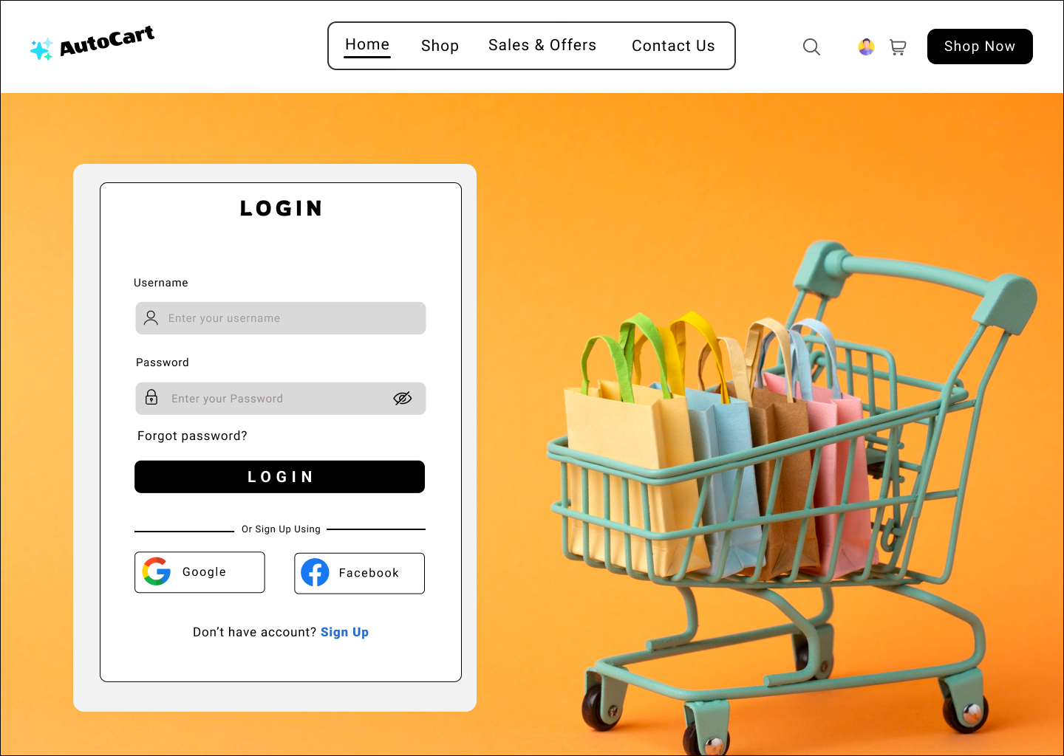
Verify login with valid username and password
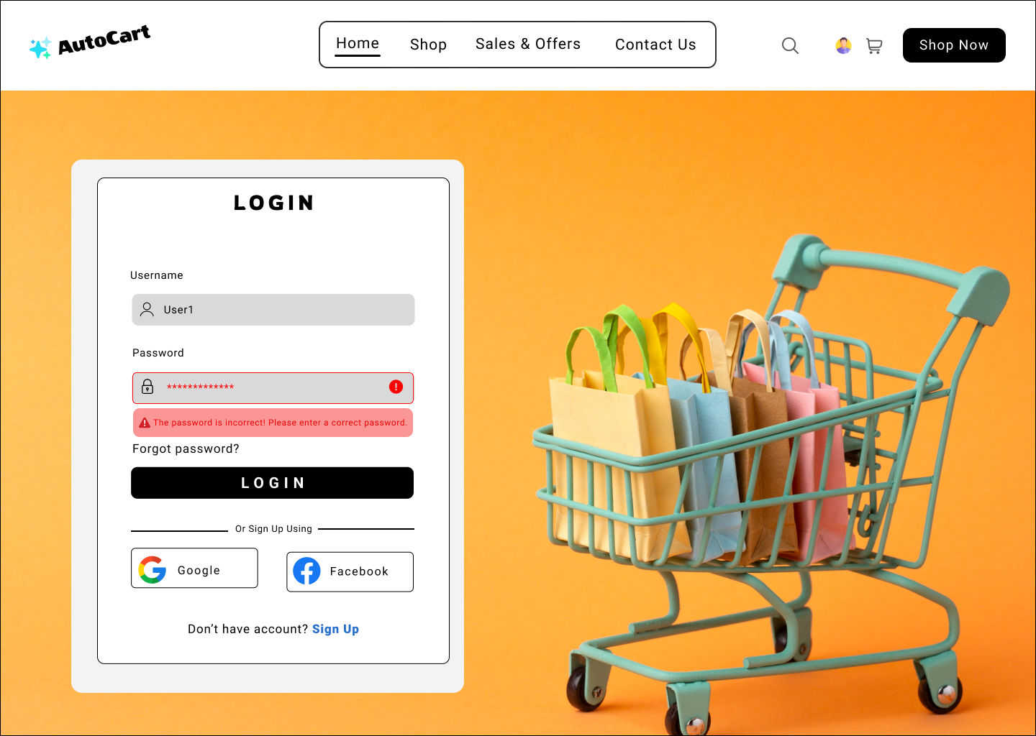
Verify login fails with invalid credentials
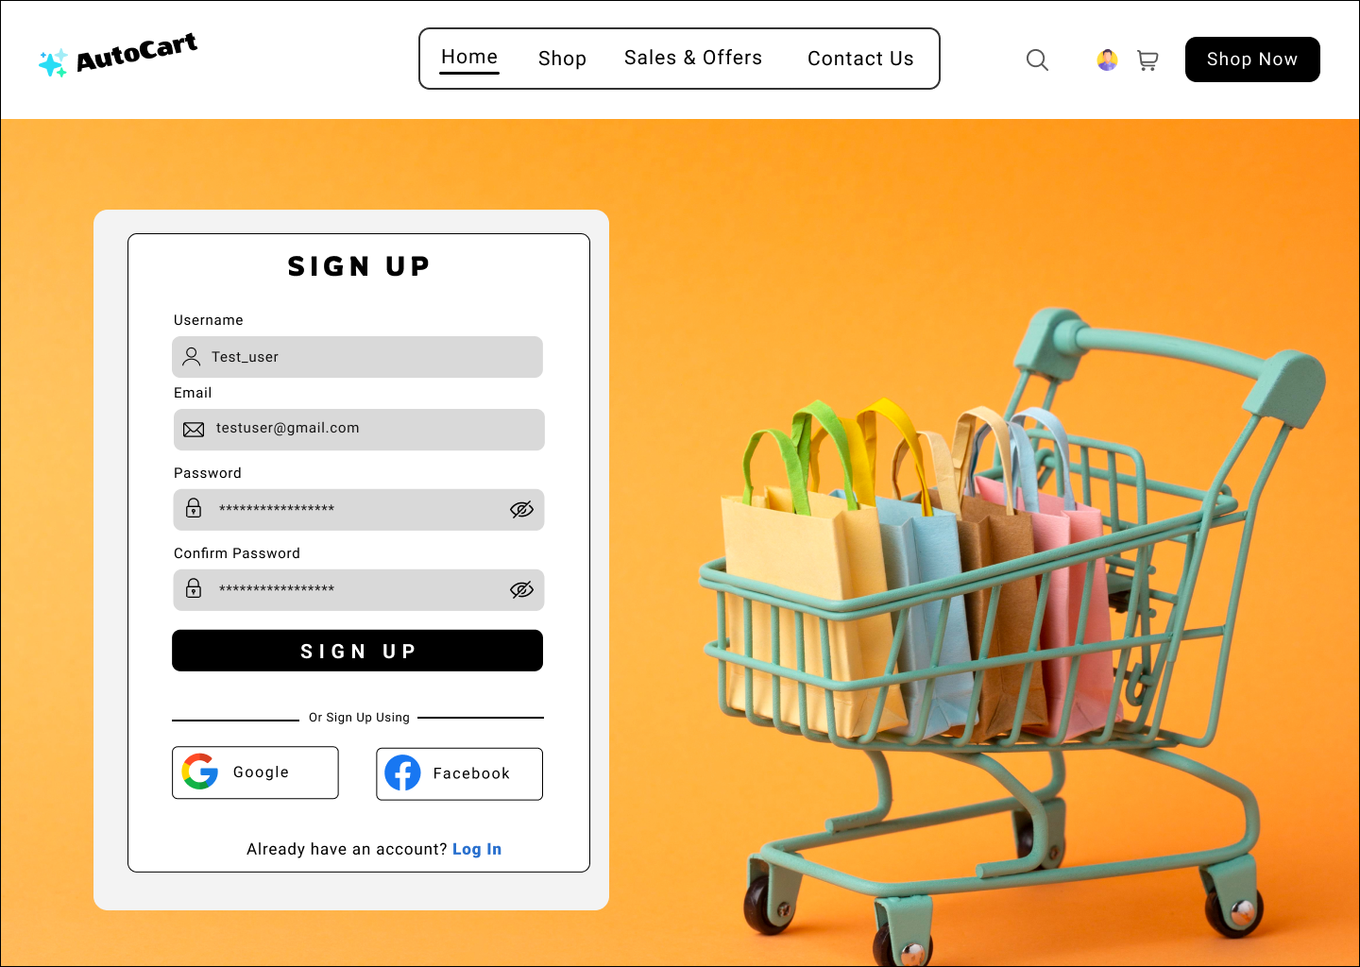
Verify user registration with valid input data
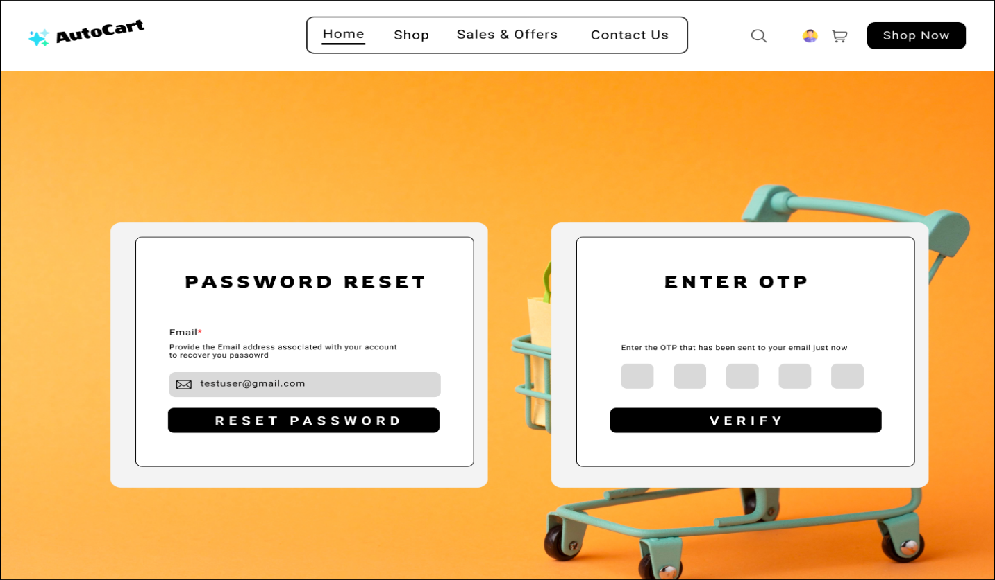
Verify password reset via email OTP

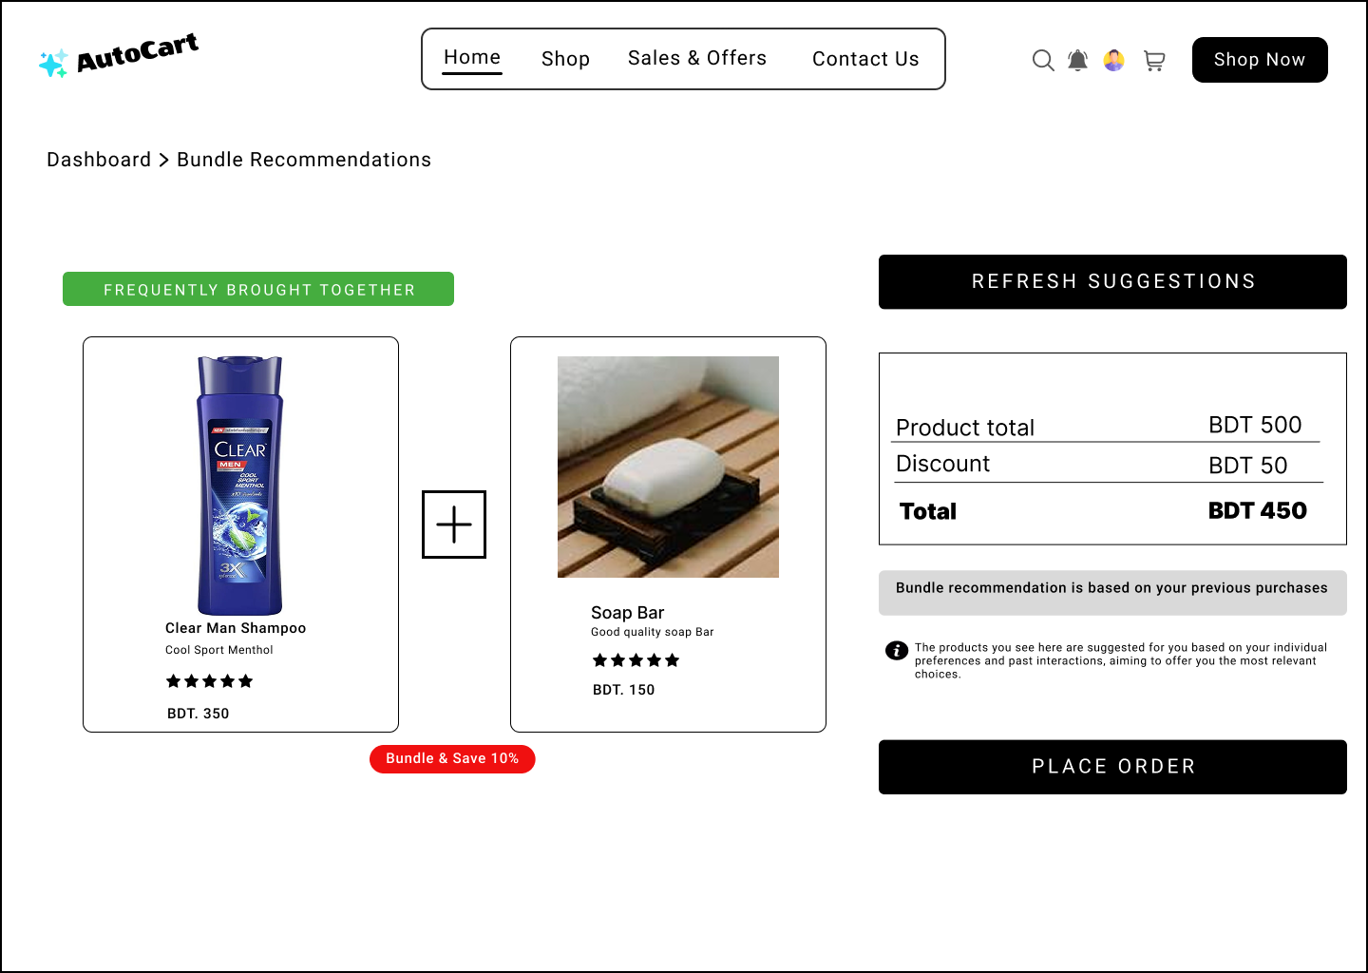
Verify smart bundle recommendation based on purchase history
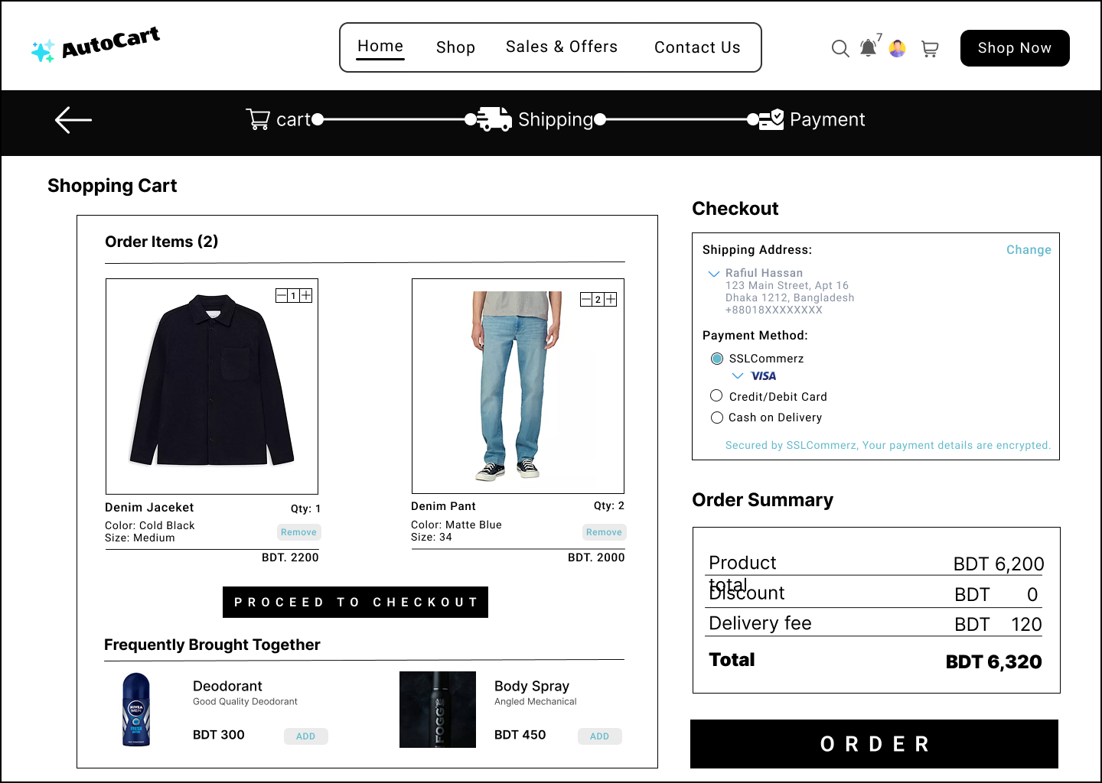
Verify adding product to cart and proceeding to checkout
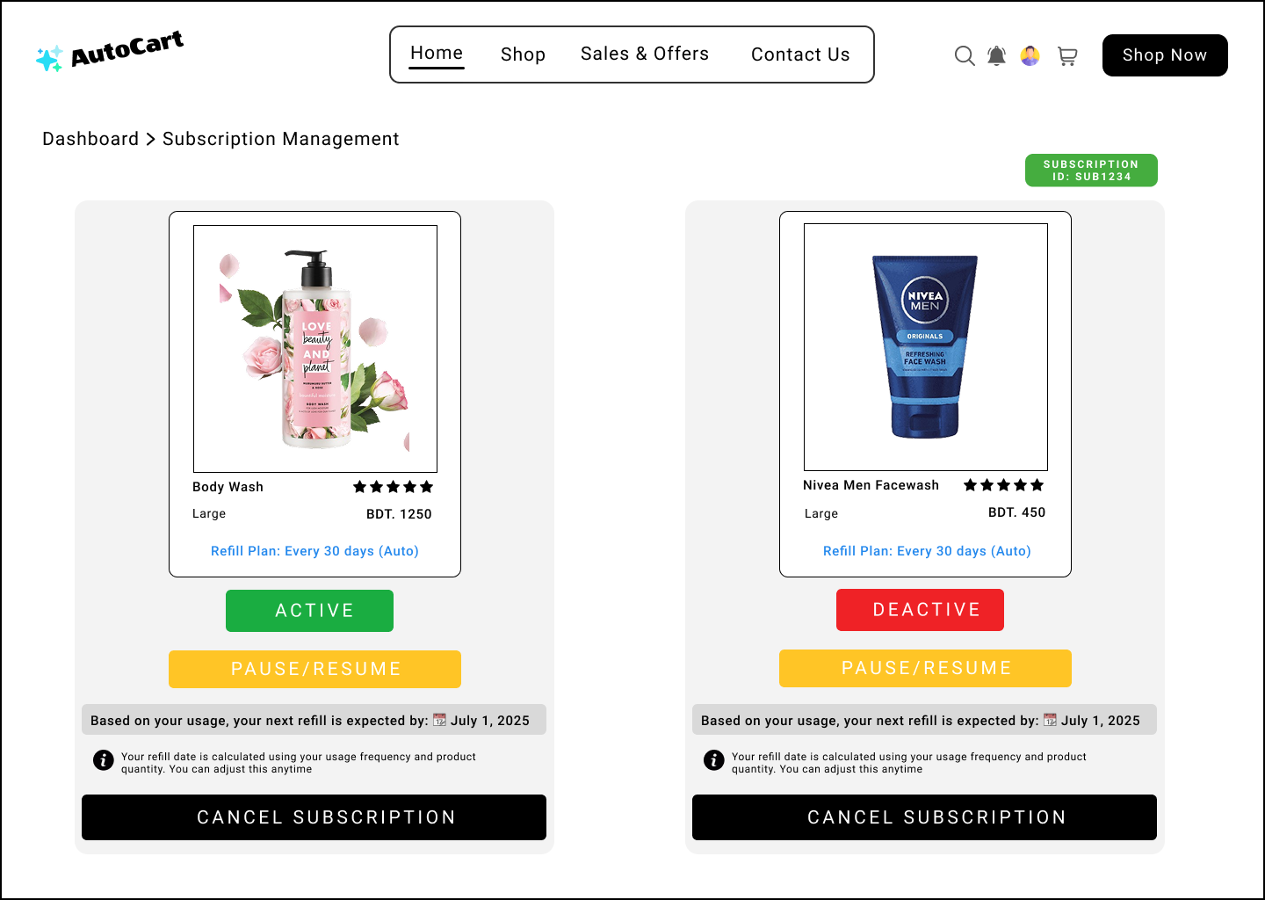
Verify subscription pause and resume functionality

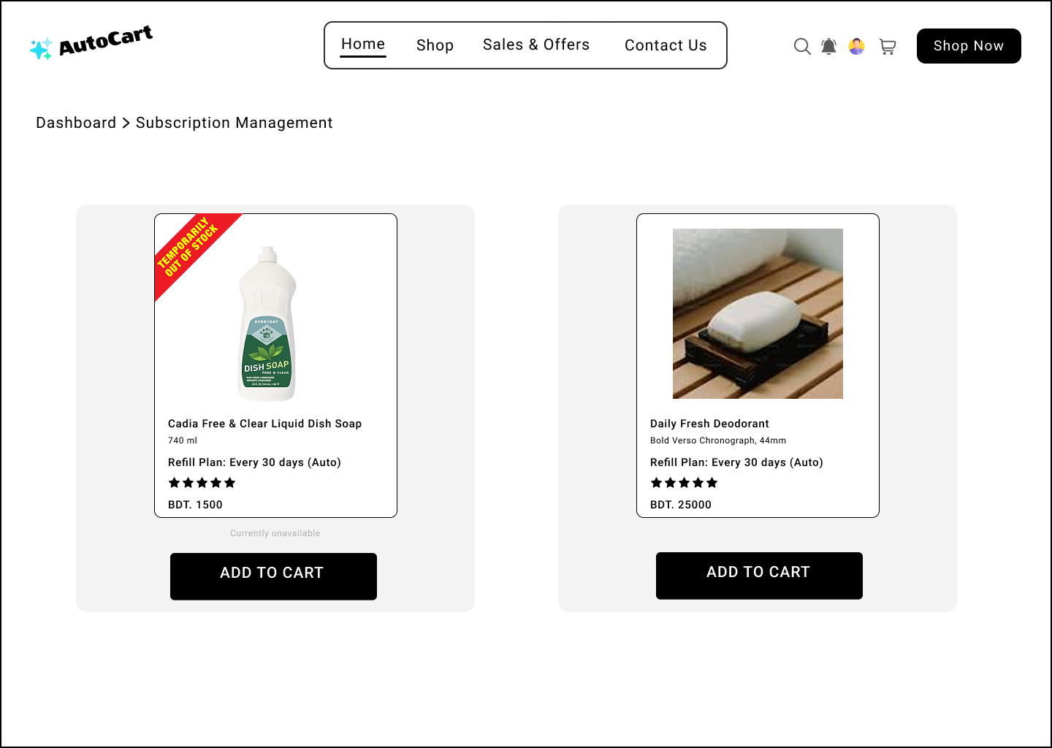
Verify real-time stock alert when product is unavailable
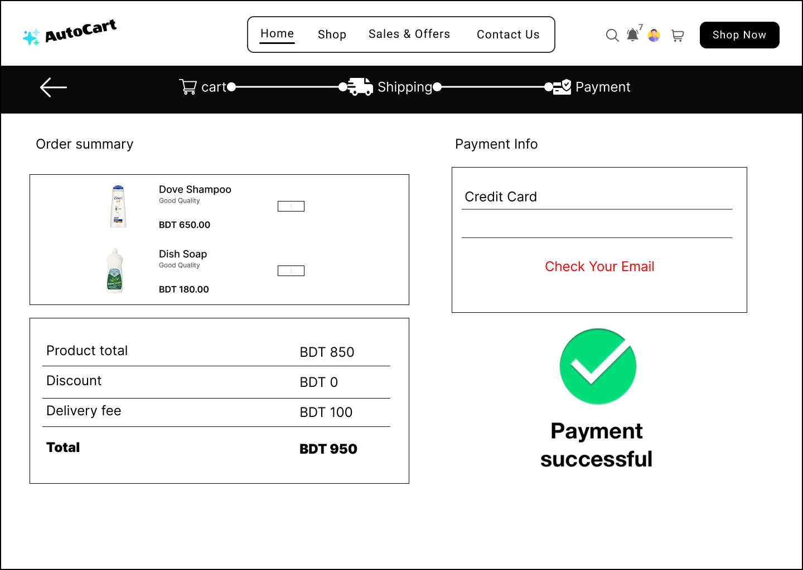
Verify successful order placement with valid payment details
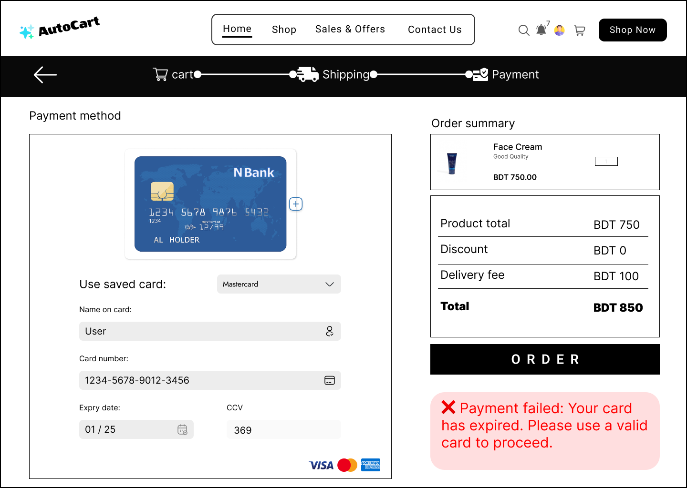
Verify successful order placement with valid payment details

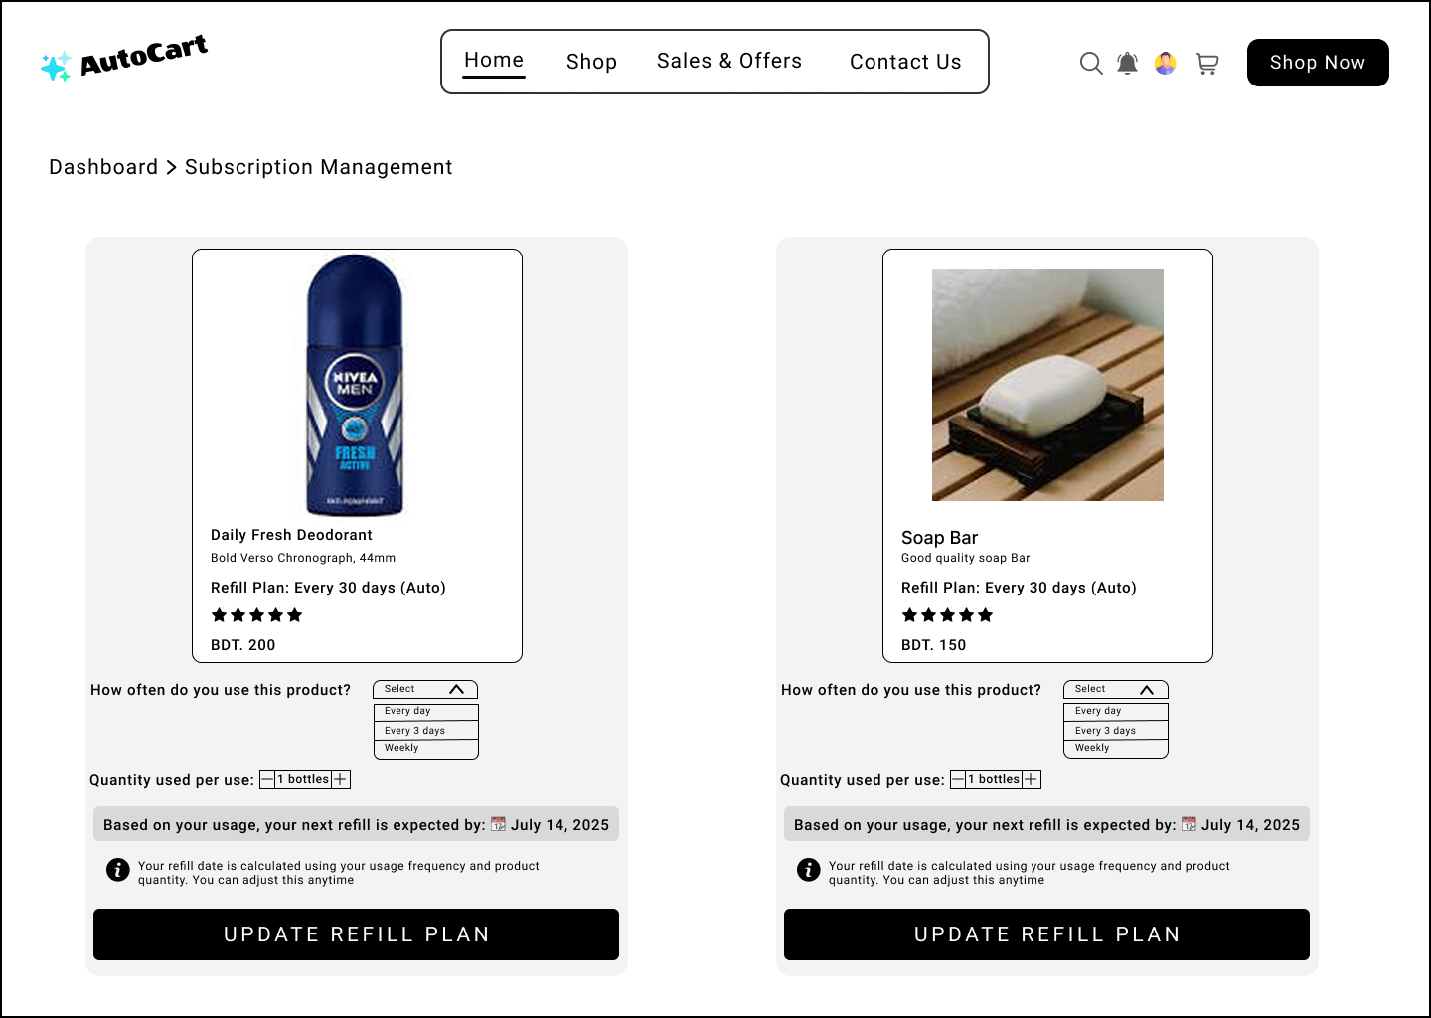
Verify refill schedule adjustment based on user consumption input
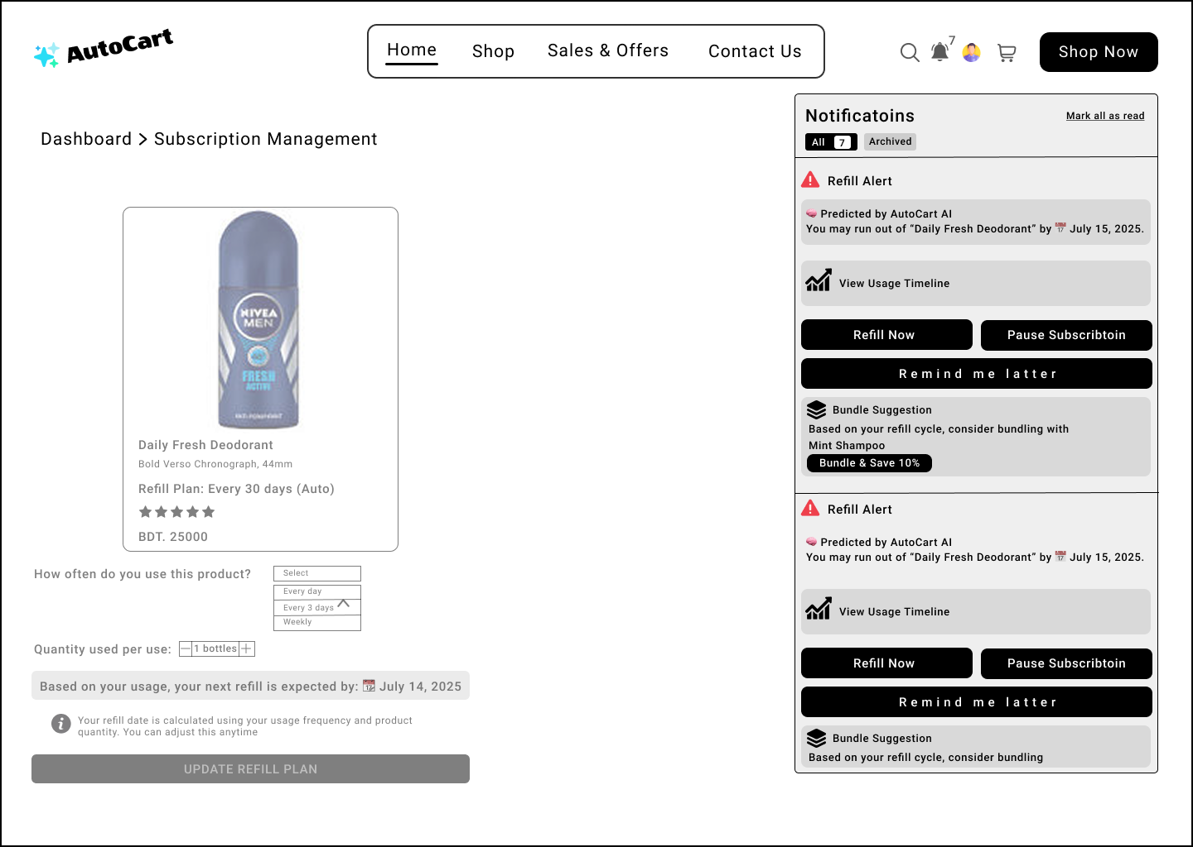
Verify accurate refill reminder notification based on predicted usage cycle
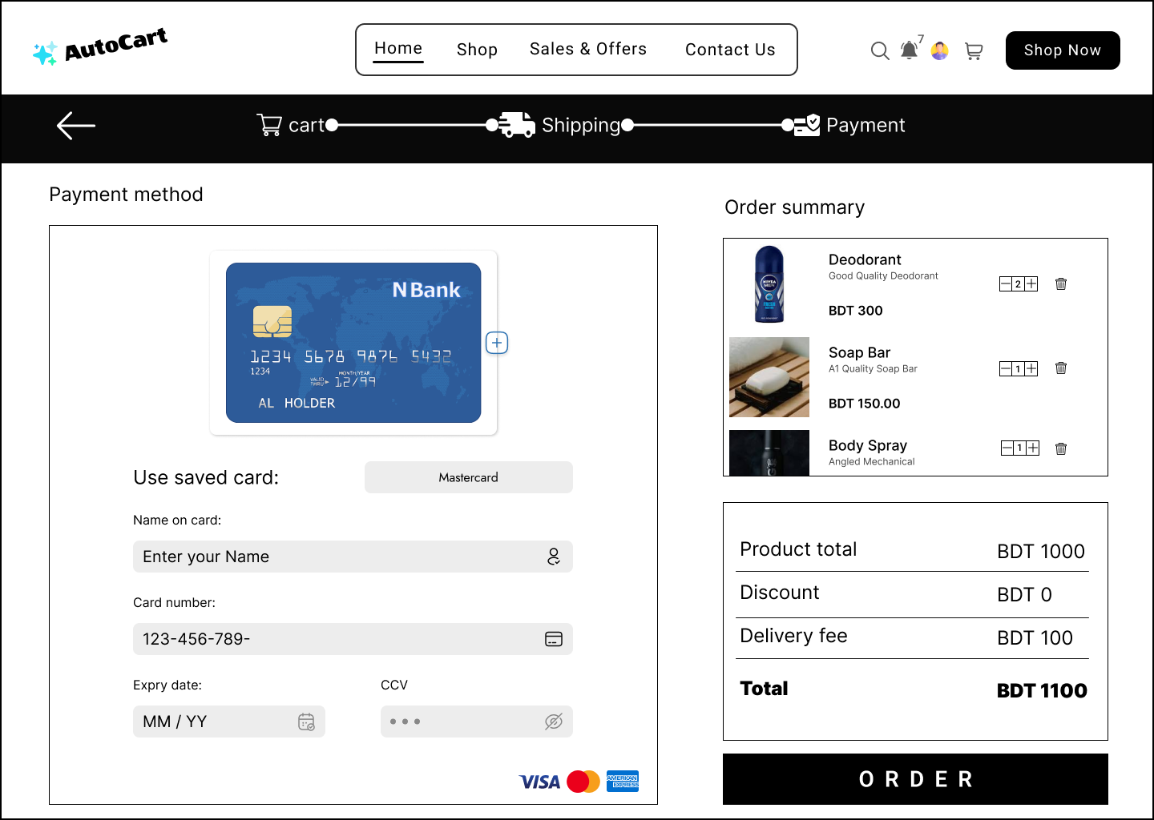
Verify secure checkout process with encrypted payment data
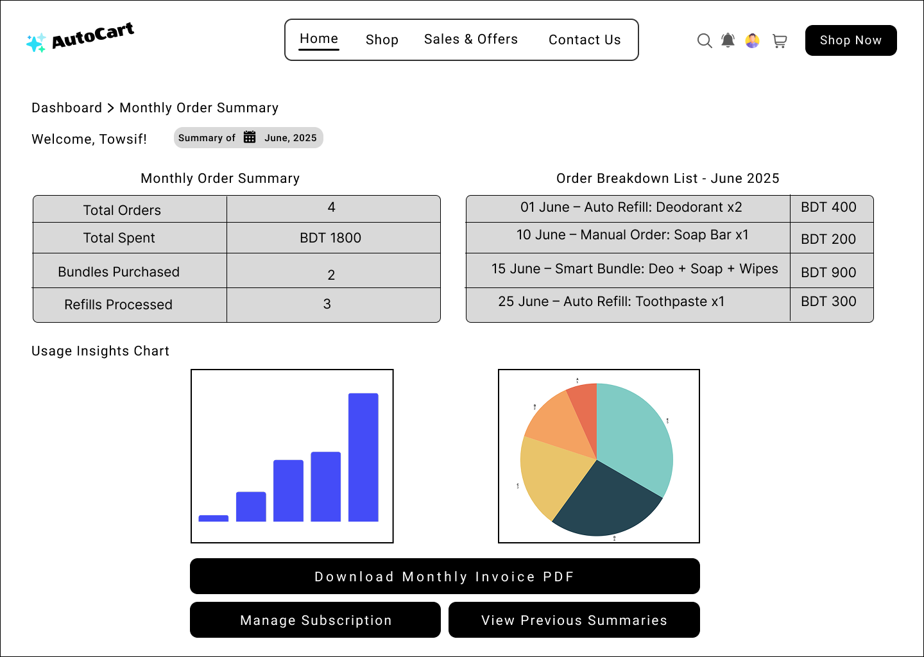
Verify accurate monthly order summary generation for user dashboard

Project Requirements
4.4.1 Budget Constraints
The overall project budget is estimated at 4,25,000 BDT, which includes costs for development, infrastructure, security, marketing, and post-launch support
Category | Estimated Cost (BDT)
AI Refill Prediction Engine Development | 1,00,000
Software Development (Frontend & Backend) | 90,000
Cloud Infrastructure (Hosting, DB, Storage) | 60,000
Third-Party API Integration (Payments, Auth) | 40,000
Subscription & Bundling Logic Implementation | 30,000
Testing & Quality Assurance (QA) | 30,000
Post-Launch Maintenance & Updates | 30,000
Marketing & User Onboarding Materials | 20,000
Security & Compliance (SSL, MFA, etc.) | 25,000
Total Budget | 4,25,000 BDT

4.4.2 Time Constraints
The projected development timeline for AutoCart is approximately 5 months, segmented into key phases such as planning, design, development, integration, and final deployment.
Phase | Estimated Duration
Requirement Analysis & Planning | 2 weeks
UI/UX Design & Wireframing | 3 weeks
AI Engine Development (Prediction) | 1 month
Backend Development (APIs & DB) | 1 month
Frontend Development (UI Logic) | 1 month
Subscription & Cart Logic Setup | 2 weeks
Integration, Testing & Deployment | 1 month
Total Estimated Time | 6 months

4.4.3 Resource Constraints
The successful execution of the AutoCart project depends on the availability of specific human and technological resources to ensure timely and efficient development.
Human Resources
- Project Manager (1) – Oversees project timelines, team coordination, and milestone tracking.
- AI/ML Engineers (2) – Develop and train the predictive refill engine and smart bundling algorithms.
- Backend Developers (2) – Implement server-side logic, subscription management, and database operations.
- Frontend Developers (2) – Build responsive and interactive user interfaces for web and mobile platforms.
- QA Engineers (2) – Conduct functionality, usability, and performance testing.
- UI/UX Designer (1) – Designs intuitive user flows and enhances customer experience.
- Marketing Strategist (1) – Plans go-to-market campaigns and handles pre-launch promotions.
Technology Resources
- Frontend Development: Next.js (React-based), Tailwind CSS
- Backend Development: Node.js with Express.js or Next.js API routes
- AI/ML Libraries: Python (scikit-learn, TensorFlow), Time-series analysis tools
- Database: PostgreSQL (relational data), Redis (caching), MongoDB
- Cloud Services: Vercel (frontend hosting), AWS/GCP (backend, storage, database)
- Security Tools: SSL, OAuth 2.0, Two-Factor Authentication (2FA), Data Encryption at Rest and
4.4.4 Environmental Constraints
- The AutoCart platform must be web-based and hosted on cloud infrastructure to ensure high availability and scalability.
- It must be fully responsive and compatible across modern web browsers and devices (mobile, tablet, desktop).
- The system should integrate smoothly with AI modules for refill prediction, requiring minimal delay in real-time recommendations.
- Consistent internet connectivity is required for key features like smart refill, notifications, and real-time bundling logic — which may limit usage in areas with poor network coverage.
- The backend should operate efficiently under various environments (Windows, Linux servers) with minimal configuration.
- All services must adhere to regional data privacy regulations depending on hosting (e.g., GDPR-compliant if deployed in the EU).

FEATURES NOT TO BE TESTED
Third-Party Application Integration & Data Usage

While AutoCart enables users to export their subscription and purchase history for personal use or integration with third-party budgeting or tracking tools, the accuracy, compatibility, and performance of such data within external applications are outside the scope of this project.

AutoCart will ensure proper data export formatting, but testing and maintenance of features within external tools remain the responsibility of those respective application developers or maintainers.

TESTING APPROACH

Testing Levels
- Unit Testing
- Developers will perform unit testing for individual features such as smart refill prediction, product bundling, subscription management, and payment processing.
- Each unit must include documented test cases, sample data, expected output, and defect reports before moving to the next testing phase.
- Unit testing will be reviewed and approved by the development team lead to ensure all modules function independently.
- System/Integration Testing

- A dedicated QA team will perform integration testing with assistance from developers.
- Tests will validate interactions between modules (e.g., auto-refill triggers shipping, bundled checkout updates delivery schedule).
- Integration with third-party services like payment gateways and delivery APIs will also be tested.
- All major defects must be resolved, and critical functionality must pass validation before advancing to user acceptance.

- User Acceptance Testing (UAT)

- Real users (test shoppers) will evaluate the full AutoCart workflow, including product selection, refill recommendations, checkout, and order tracking.
- UAT will run in parallel with existing manual subscription methods (e.g., regular reminder emails) for a fixed period.
- Feedback from UAT will be collected to identify usability gaps and minor bugs before official launch.

Test Tools
Testing for the AutoCart platform will utilize a combination of automated testing tools, performance testing frameworks, and bug tracking systems to ensure a robust and efficient QA process.

- Automated Testing Tools

Visual Studio Code with Jest & React Testing Library

- Purpose: Unit and component testing for frontend features such as product cards, subscription flows, and dynamic refill alerts.
- Usage: Validate UI logic, interaction states, and conditional rendering in the Next.js-based frontend.

Postman
- Purpose: API testing for endpoints including smart refill triggers, cart operations, and user subscription management.
- Usage: Validate request/response payloads, authentication flows, and error handling for backend APIs.

- Performance Testing Tools

Apache JMeter
- Purpose: Simulate user traffic and assess system performance under load.
- Usage: Test scenarios like peak-time cart checkouts, large bundle creation, and batch refill notifications.

- Bug Tracking & Reporting Tool

Trello or Jira
- Purpose: Track bugs, log defects, and organize the QA workflow.
- Usage: Assign issues to developers, prioritize critical bugs, and maintain visibility of testing progress across the team.

Meetings
- The QA team will conduct weekly meetings to assess testing progress, review identified defects, and ensure alignment with testing goals.
- Bi-weekly coordination meetings will be held between the QA lead, development team, and project manager to ensure smooth integration and timely resolution of cross-functional issues.
- Ad-hoc/emergency meetings may be scheduled when critical bugs or high-priority issues arise that require immediate attention and collaborative resolution.

TEST CASES/TEST ITEMS
Project Name: Project Name: AutoCart: Intelligent E-Commerce with Predictive Auto-Refill & Smart Bundling |  |  | Test Designed by: FARJANA YESMIN OPI
Test Case ID: AutoCart-FR-001 |  |  | Test Designed date: 01/06/2025
Test Priority (Low, Medium, High): Medium |  |  | Test Executed by: MD. ABU TOWSIF
Module Name: Login Session |  |  | Test Execution date: 01/06/2025
Test Title: Verify login with valid username and password
Description: Test the website login page with correct credentials
Precondition: User must have valid username and password
Dependencies: User account must be registered in the database
Test Steps | Test Data | Expected Results |  | Actual Results | Status (Pass/Fail)
- Go to the website  - Enter username  - Enter password  - Click submit | Username: User1  Password: 321 | User should login into the application |  | As expected | Pass
Post Condition: User is validated with database and successfully login to account. The account session details are logged in the database.

Project Name: Project Name: AutoCart: Intelligent E-Commerce with Predictive Auto-Refill & Smart Bundling |  |  | Test Designed by: FARJANA YESMIN OPI
Test Case ID: AutoCart-FR-002 |  |  | Test Designed date: 01/06/2025
Test Priority (Low, Medium, High): High |  |  | Test Executed by: SHOHAN
Module Name: Login Session |  |  | Test Execution date:02/06/2025
Test Title: Verify login fails with invalid credentials
Description: Ensure the system does not allow login when incorrect username or password is entered
Precondition: Login page is accessible
Dependencies: Login system must be active
Test Steps | Test Data | Expected Results |  | Actual Results | Status (Pass/Fail)
- Go to the website  - Enter username  - Enter invalid password  - Click submit | Username: User1  Password: 123 | System should show error and deny login |  | As expected | Pass
Post Condition: User is not logged in. No session is created, and an appropriate error message is displayed.

Project Name: Project Name: AutoCart: Intelligent E-Commerce with Predictive Auto-Refill & Smart Bundling |  |  | Test Designed by: FARJANA YESMIN OPI
Test Case ID: AutoCart-FR-003 |  |  | Test Designed date: 17/06/2025
Test Priority (Low, Medium, High): High |  |  | Test Executed by: RAFIUL HASSAN
Module Name: User Registration |  |  | Test Execution date: 03/06/2025
Test Title: Verify user registration with valid input data
Description: Check if new users can register with correct data
Precondition: Registration page is accessible
Dependencies: Registration module must be active
Test Steps | Test Data | Expected Results |  | Actual Results | Status (Pass/Fail)
- Go to registration page  - Fill in valid data  - Submit the form | Username: Test_user  Email: testuser@gmail.com  Password: pass | User account should be created and success message should be shown |  | As expected | Pass
Post Condition: User account is created and saved in the database

Project Name: Project Name: AutoCart: Intelligent E-Commerce with Predictive Auto-Refill & Smart Bundling |  |  | Test Designed by: FARJANA YESMIN OPI
Test Case ID: AutoCart-FR-004 |  |  | Test Designed date: 03/06/2025
Test Priority (Low, Medium, High): High |  |  | Test Executed by: SHOHAN
Module Name: Password Recovery |  |  | Test Execution date: 03/06/2025
Test Title: Verify password reset via email OTP
Description: Test the ability to reset password using a valid OTP sent to the user’s registered email
Precondition: User must have a registered email
Dependencies: OTP email service must be active
Test Steps | Test Data | Expected Results |  | Actual Results | Status (Pass/Fail)
- Click “Forgot Password” link  - Enter received OTP  - Enter new password & confirm | Username: Test_user  OTP: 123456  New Password: pass123 | OTP is received, verified, and password reset is successful |  | As expected | Pass
Post Condition: Password is updated and login is possible with the new password

Project Name: Project Name: AutoCart: Intelligent E-Commerce with Predictive Auto-Refill & Smart Bundling |  |  | Test Designed by: FARJANA YESMIN OPI
Test Case ID: AutoCart-FR-005 |  |  | Test Designed date: 13/06/2025
Test Priority (Low, Medium, High): High |  |  | Test Executed by: MD. ABU TOWSIF
Module Name: Predictive Auto-Refill |  |  | Test Execution date: 14/06/2025
Test Title: Verify AI-based refill suggestion appears after product depletion
Description: Check if AI suggests refill when a product runs low or is used up
Precondition: User has purchased a product with refill tracking enabled
Dependencies: AI prediction model and product usage tracking must be active
Test Steps | Test Data | Expected Results |  | Actual Results | Status (Pass/Fail)
- Log in to user account  - Simulate product usage until depletion  - Check homepage/dashboard for refill alert | Username: Test_user  Product: Camera | Refill suggestion appears for depleted item |  | As expected | Pass
Post Condition: System recommends refill and shows it on dashboard or cart

Project Name: Project Name: AutoCart: Intelligent E-Commerce with Predictive Auto-Refill & Smart Bundling |  |  | Test Designed by: A. F. M. RAFIUL HASSAN
Test Case ID: AutoCart-FR-006 |  |  | Test Designed date: 05/06/2025
Test Priority (Low, Medium, High): Medium |  |  | Test Executed by: RAFIUL HASSAN
Module Name: Smart Bundle Recommendation |  |  | Test Execution date: 05/06/2025
Test Title: Verify smart bundle recommendation based on purchase history
Description: Ensure the system suggests bundles of products frequently bought together based on past purchase history
Precondition: User must be logged in and that user have at least two purchased item in the database
Dependencies: The recommendation system must be running against test database
Test Steps | Test Data | Expected Results |  | Actual Results | Status (Pass/Fail)
- Log into the AutoCart account  - Go to Bundle Recommendations  - Refresh or load suggestions.  - Verify bundle with item-1 and item-2 appears, also with “Frequently bought together” and correct discount/pricing  - Click on “Place Order” | Username: tuser1  Password: 1234  Purchase history:  Products: Item-1 and item-2 | The recommendation bundle shown with item-1 + item-2 appears with option "Frequently brought together" and correct discount, update the total prices. No changes are made to order. |  | As expected | Pass
Post Condition: No changes made to order, as user checks the bundle recommendations.

Project Name: Project Name: AutoCart: Intelligent E-Commerce with Predictive Auto-Refill & Smart Bundling |  |  | Test Designed by: A. F. M. RAFIUL HASSAN
Test Case ID: AutoCart-FR-007 |  |  | Test Designed date: 06/06/2025
Test Priority (Low, Medium, High): High |  |  | Test Executed by: FARJANA YESMIN OPI
Module Name: Shopping Cart & Checkout |  |  | Test Execution date: 07/06/2025
Test Title: Verify adding product to cart and proceeding to checkout.
Description: Ensure a user can add an in-stock product to cart and complete checkout successfully
Precondition: User must be logged in and has items in the cart, and a valid address has been provided.
Dependencies: Payment gateway must be reachable.
Test Steps | Test Data | Expected Results |  | Actual Results | Status (Pass/Fail)
- Log into the AutoCart account  - Go to Shopping Cart  - Click “Add to cart or Remove”  - Proceed to the checkout.  - Select or change shipping address.  - Select payment method.  - Click on “Order” | Username: tuser2  Password: 1234  Product: Denim Jacket  Price: 2200 BDT  Payment Method: SSLCommerz  Product: Denim Pant  Price: 2000 BDT | The payment should be made and the order should be successfully ordered also stored in the database with order and payment information. |  | As expected | Pass
Post Condition: Item added to the checkout, Order successfully placed.

Project Name: Project Name: AutoCart: Intelligent E-Commerce with Predictive Auto-Refill & Smart Bundling |  |  | Test Designed by: A. F. M. RAFIUL HASSAN
Test Case ID: AutoCart-FR-008 |  |  | Test Designed date: 05/06/2025
Test Priority (Low, Medium, High): Medium |  |  | Test Executed by: FARJANA YESMIN OPI
Module Name: Subscription Management |  |  | Test Execution date: 06/06/2025
Test Title: Verify subscription pause and resume functionality
Description: Validate that pausing an active subscription halts refill/billing and resuming recalculates next refill correctly
Precondition: User must be logged in and Active subscription exists for a product and next refill date in future
Dependencies: Subscription service and scheduler must be active.
Test Steps | Test Data | Expected Results |  | Actual Results | Status (Pass/Fail)
- Log into the AutoCart account  - Go to My Subscriptions.  - Verify status “Active” and next refill date.  - Click “Pause” or “Resume” and confirm.  - Successful changes with subscription status and next refill calculation. | Username: tuser3  Password: 1234  Subscription ID: SUB1234 for “AutoRefillProduct” and the next refill is on July 1, 2025. | The user should successfully “Pause” or “Resume” the subscription with updated refill date. |  | Not as expected | Fail
Post Condition: Subscription remains active with next refill scheduled.

Project Name: Project Name: AutoCart: Intelligent E-Commerce with Predictive Auto-Refill & Smart Bundling |  |  | Test Designed by: MD. SHOHANUR RAHMAN SHOHAN
Test Case ID: AutoCart-FR-009 |  |  | Test Designed date: 06/06/2025
Test Priority (Low, Medium, High): High |  |  | Test Executed by: MD. ABU TOWSIF
Module Name: Inventory Management / Stock Alert |  |  | Test Execution date: 08/06/2025
Test Title: Verify real-time stock alert when product is unavailable
Description: Ensure the system displays a clear “Out of Stock” alert when a user attempts to view or add an unavailable product
Precondition: User is logged in; product exists in catalog but is marked as out of stock
Dependencies: Inventory status must be correctly synced in the backend database
Test Steps | Test Data | Expected Results |  | Actual Results | Status (Pass/Fail)
- Log into the AutoCart account  - Navigate to product catalog or use search  - Select an out-of-stock product  - Try to add product to cart | Username: user1  Password: 321  Product: Dish Soap  Stock = 0 in database  Click “Add to Cart” | Product card should display "Out of Stock" badge, and System should prevent action and show warning. |  | As expected | Pass
Post Condition: Product remains unavailable until re-stocked. UI prevents ordering and reflects accurate inventory.

Project Name: Project Name: AutoCart: Intelligent E-Commerce with Predictive Auto-Refill & Smart Bundling |  |  | Test Designed by: MD. SHOHANUR RAHMAN SHOHAN
Test Case ID: AutoCart-FR-010 |  |  | Test Designed date: 09/06/2025
Test Priority (Low, Medium, High): High |  |  | Test Executed by: MD. ABU TOWSIF
Module Name: Checkout & Payment |  |  | Test Execution date: 11/06/2025
Test Title: Verify successful order placement with valid payment details
Description: Ensure the checkout system processes the order correctly when valid payment details are provided
Precondition: User is logged in and has items in the cart
Dependencies: Payment gateway must be active and reachable
Test Steps | Test Data | Expected Results |  | Actual Results | Status (Pass/Fail)
- Log into the AutoCart account  - Add items to cart  - Go to Checkout page  - Enter valid payment details  - Click "Place Order"  - Return to Order Successful page with all details and check email. | Username: user1  Password: 321  Product: Shampoo (৳650), Dish Soap (৳180)  Cart Items Total: ৳830  Cart Items Total: ৳830  Method: Credit Card (SSLCommerz), Card No: 1234-XXXX-XXXX-5678  Email: user1@gmail.com | Order summary is displayed from payment form accepts data and confirmation message appears, order saved, and order receipt received. |  | As expected | Pass
Post Condition: Order is added to the user’s order history. Confirmation receipt is generated. Payment is marked as successful in system logs

Project Name: Project Name: AutoCart: Intelligent E-Commerce with Predictive Auto-Refill & Smart Bundling |  |  | Test Designed by: MD. SHOHANUR RAHMAN SHOHAN
Test Case ID: AutoCart-FR-011 |  |  | Test Designed date: 09/06/2025
Test Priority (Low, Medium, High): High |  |  | Test Executed by: RAFIUL HASSAN
Module Name: Checkout & Payment |  |  | Test Execution date: 10/06/2025
Test Title: Verify system behavior with expired payment method
Description: Ensure the system detects and blocks transactions made using an expired card or outdated payment credentials
Precondition: User must be logged in and have at least one item in the cart
Dependencies: Payment gateway must be active and capable of detecting expiry
Test Steps | Test Data | Expected Results |  | Actual Results | Status (Pass/Fail)
- Log into the AutoCart account  - Add items to cart  - Go to Checkout page  - Enter valid payment details  - Click "Place Order"  - User cannot complete order | Username: user1  Password: 321  Product: Face Cream (BDT 750)  Delivery Fee BDT 100  Cart Items Total: BDT 850  Method: Credit Card (SSLCommerz), Card No: 1234-5678-9012-3456  Name: User  Expiry: 01/23  CCV: 369 | Cart summary shown and system should detect expiry. System should reject payment and show error message. Order is not placed, card must be updated |  | Not as expected | Fail
Post Condition: Order is not processed. User is prompted to update payment method. Error message is displayed and logged in system.

Project Name: Project Name: AutoCart: Intelligent E-Commerce with Predictive Auto-Refill & Smart Bundling |  |  | Test Designed by: MD. ABU TOWSIF
Test Case ID: AutoCart-FR-012 |  |  | Test Designed date: 09/06/2025
Test Priority (Low, Medium, High): High |  |  | Test Executed by: SHOHAN
Module Name: Refill Prediction Engine |  |  | Test Execution date: 11/06/2025
Test Title: Verify refill schedule adjustment based on user consumption input
Description: Validate that the system correctly updates the next refill prediction based on updated user usage input
Precondition: User must be logged in and have at least one active subscription item
Dependencies: User account must be registered in the database
Test Steps | Test Data | Expected Results |  | Actual Results | Status (Pass/Fail)
- Navigate to the “My Subscriptions” dashboard  - Select a subscribed item (e.g., Shampoo)  - Enter new consumption frequency (e.g., 1 bottle every 10 days)  - Submit updated usage data  - Navigate to next predicted refill date | Username: User1  Password: 321  Product: Shampoo  Usage input: 1 per 10 days | System should accept new usage input and adjust the predicted refill date accordingly. |  | As expected | Pass
Post Condition: System updates the refill logic for that item. Dashboard now reflects updated refill prediction. New schedule is stored in the backend and triggers new notification timing.

Post Condition: System updates the refill logic for that item. Dashboard now reflects updated refill prediction. New schedule is stored in the backend and triggers new notification timing.
Project Name: Project Name: AutoCart: Intelligent E-Commerce with Predictive Auto-Refill & Smart Bundling |  |  | Test Designed by: MD. ABU TOWSIF
Test Case ID: AutoCart-FR-013 |  |  | Test Designed date: 10/06/2025
Test Priority (Low, Medium, High): High |  |  | Test Executed by: FARJANA YESMIN OPI
Module Name: Smart Notification System |  |  | Test Execution date: 12/06/2025
Test Title: Verify accurate refill reminder notification based on predicted usage cycle
Description: Test whether users receive correct refill notifications based on their usage history and prediction logic
Precondition: User is logged in and has an active subscription with at least 1 refill cycle completed
Dependencies: User account must be registered in the database
Test Steps | Test Data | Expected Results |  | Actual Results | Status (Pass/Fail)
- Log into the AutoCart account  - Navigate to the “Notifications” or “Smart Refill Alerts” section  - Simulate consumption data (e.g., product lasts for 10 days)  - Wait until predicted threshold (e.g., Day 8–9)  - Check if refill reminder notification appears | Product: Face Wash  Usage Frequency: 1 unit every 10 days  Product: Toothpaste  Usage Frequency: 1 unit every 20 days | User should receive a smart notification with an estimated refill date, tagged as "Predicted by AutoCart AI". |  | As expected | Pass
Post Condition: A refill reminder notification is logged in the user’s notification history and available in the dashboard until dismissed or acted upon.

Project Name: Project Name: AutoCart: Intelligent E-Commerce with Predictive Auto-Refill & Smart Bundling |  |  | Test Designed by: MD. ABU TOWSIF
Test Case ID: AutoCart-FR-014 |  |  | Test Designed date: 12/06/2025
Test Priority (Low, Medium, High): High |  |  | Test Executed by: RAFIUL HASSAN
Module Name: Checkout & Payment Security Module |  |  | Test Execution date: 13/06/20255
Test Title: Verify secure checkout process with encrypted payment data
Description: Ensure the checkout system uses encrypted communication and processes payment securely.
Precondition: User is logged in, has items in the cart, and a valid payment method is configured.
Dependencies: User account must be registered in the database
Test Steps | Test Data | Expected Results |  | Actual Results | Status (Pass/Fail)
- Log into the AutoCart account  - Add one or more items to the cart  - Proceed to the checkout page  - Enter valid payment information (e.g., card/mobile banking)  - Complete the payment process  - Monitor network activity and inspect security headers (optional for developer validation) | Product: Protein Powder  Price: 1,200 BDT  Payment Method: SSLCommerz (Credit Card)  Product: Shampoo  Price: 650 BDT  Payment Method: Mobile Banking (bKash/Nagad) | Payment should be completed successfully using HTTPS, and payment data should be transmitted securely using encryption. |  | As expected | Pass
Post Condition: Transaction is recorded in the user’s order history, and a confirmation receipt is generated and sent via email/SMS.

Project Name: Project Name: AutoCart: Intelligent E-Commerce with Predictive Auto-Refill & Smart Bundling |  |  | Test Designed by: MD. ABU TOWSIF
Test Case ID: AutoCart-FR-015 |  |  | Test Designed date: 12/06/2025
Test Priority (Low, Medium, High): High |  |  | Test Executed by: FARJANA YESMIN OPI
Module Name: Order Summary Dashboard |  |  | Test Execution date: 14/06/2025
Test Title: Verify accurate monthly order summary generation for user dashboard
Description: Test if the dashboard correctly summarizes all user orders made within a specific month.
Precondition: User is logged in, has items in the cart, and a valid payment method is configured.
Dependencies: User has completed at least one successful order within the current month.
Test Steps | Test Data | Expected Results |  | Actual Results | Status (Pass/Fail)
- Log into the AutoCart account  - Navigate to the “Dashboard” or “My Orders” section  - Filter orders by the current month (e.g., June 2025)  - View the monthly summary (including product names, prices, total amount, and delivery status)  - Compare with actual order history data | Order 1: Toothpaste, Qty: 2, Price: 200 BDT  Order 2: Body Lotion, Qty: 1, Price: 400 BDT | The dashboard should accurately display all orders placed in the selected month, with correct total amount, item list, and delivery statuses.. |  | Not as expected | Fail
Post Condition: Monthly order data remains visible in the dashboard for user reference, and can be exported or used for analytics.

ITEM PASS/FAIL CRITERIA
The testing process for the AutoCart system will be considered complete when the following criteria are satisfied:

- Core Functionality Verification: All essential features — including smart refill prediction, personalized bundle creation, subscription management, and order checkout — must function correctly according to defined requirements. Any module failing its expected outcome will be marked as Fail.

- Data Accuracy & Integrity: User-related data (e.g., cart contents, refill schedules, account preferences) must be stored and retrieved without errors. Any mismatched or lost data during operations will result in a Fail.

- System Stability & Error Handling: The system must operate without crashes or critical errors during normal use. Smooth navigation and proper error feedback are mandatory. Unhandled exceptions or user-facing bugs will be treated as Fail conditions.

- Performance Benchmarks: The application should handle high-traffic situations such as flash sales or peak hours without slowing down. If page load times or order processing exceeds the acceptable threshold (e.g., 2 seconds), it will be marked as Fail.

- User Acceptance & Expectations: All features must align with user requirements, including a seamless shopping experience, timely refill suggestions, and accurate product bundling. Any deviation from user expectations as defined in acceptance criteria will lead to a Fail.

- Accessibility & Usability: The interface must be intuitive for a wide range of users. If any user struggles with navigation, text readability, or overall experience due to poor UI/UX or lack of accessibility features, it will result in a Fail.

Out of the 15 test cases executed for the AutoCart project, 12 test cases have passed, while 3 encountered issues. This results in a pass rate of approximately 80% and a fail rate of 20%. Despite a few failed cases, the high success rate indicates a stable and well-performing system. Fixing the failed items will further enhance the robustness and user satisfaction of AutoCart.

TEST DELIVERABLES

- Test Plan
A comprehensive document outlining the overall testing strategy, objectives, scope, testing environment, and schedule. It includes test coverage for AutoCart features like AI-powered refill prediction, smart bundling, and subscription management.

- Test Cases
A collection of detailed test cases that define test inputs, execution conditions, expected outcomes, and pass/fail criteria. These include scenarios like automated refill triggers, personalized bundle generation, and payment gateway validation.

- Test Execution Logs
Logs recording the results of executed test cases, including timestamps, outcomes (pass/fail), issues encountered, and relevant screenshots or logs. These help in auditing and issue traceability.

- Defect Reports
Structured documentation of all bugs and issues identified during testing. Each report includes the defect ID, description, severity, steps to reproduce, and resolution status to assist developers in fixing the issues efficiently.

- Test Summary Report
A final report summarizing testing outcomes, highlighting the number of test cases executed, success rates, unresolved bugs, and overall system readiness for deployment.
- Screen Prototypes & UI Mockups
Visual layouts and interaction models of major screens such as the cart interface, refill suggestions, subscription control, and checkout flow, which were used as references during testing.

- Turnover Documentation
A formal document handed over at the end of the testing phase, detailing test completion status, critical issues (if any), and transition notes for deployment and maintenance teams.

STAFFING AND TRAINING NEEDS
Staffing Requirements
- 1 Full-Time Tester: Dedicated to system, integration, and acceptance testing phases. Initially involved part-time during early development and assigned full-time approximately halfway through the project. If a dedicated tester is unavailable, the project manager or test lead will take on testing responsibilities.
- 2 AI/ML Engineers: Support testing related to AI-powered features such as refill prediction and smart bundling.
- 2 Backend Developers: Assist with unit testing, bug fixing, and integration testing.
- 2 Frontend Developers: Support UI testing and usability verification.
- Project Manager/Test Lead: Oversees testing activities, defect management, and ensures testing quality and schedule adherence.
Training Requirements
- Testers and Developers: Training on AutoCart’s key features, including AI refill prediction models, subscription management workflows, smart bundling logic, and payment integration.
- Operations Staff: Training on monitoring AI model outputs, managing subscription adjustments, and handling customer service workflows.
- Support and Sales Teams: Training to assist users with subscription management, auto-refill settings, and troubleshooting common issues.
- Security Team: Training on implementing and monitoring multi-factor authentication, data privacy regulations, and secure transaction processing.

RESPONSIBILITIES

Task | Project Manager | Dev Team | Test Team | AI Specialist | Client
Acceptance Test Documentation & Execution | x | x | x |  | x
System Integration Documentation & Execution | x | x | x
Unit Test Documentation & Execution |  | x | x
System Design Reviews | x | x | x | x
Detailed Design Reviews | x | x | x | x
Test Procedures and Rules | x |  | x
AI Refill Prediction Model Evaluation & Validation | x |  |  | x
Smart Bundling & Personalization Logic Review |  | x |  | x
API & Payment Gateway Integration Testing | x | x | x
Change Control & Regression Testing | x | x | x | x

TESTING SCHEDULE
Time has been allocated within the project plan for the following testing activities. The specific dates and times for each activity are defined in the project plan timeline. The persons required for each process are detailed in the project timeline and plan as well. Coordination of the personnel required for each task, test team, development team, management and customer will be handled by the project manager in conjunction with the development and test team leaders. Schedule must be done using any project management tool. Don’t make the schedule using MS word/ excel.

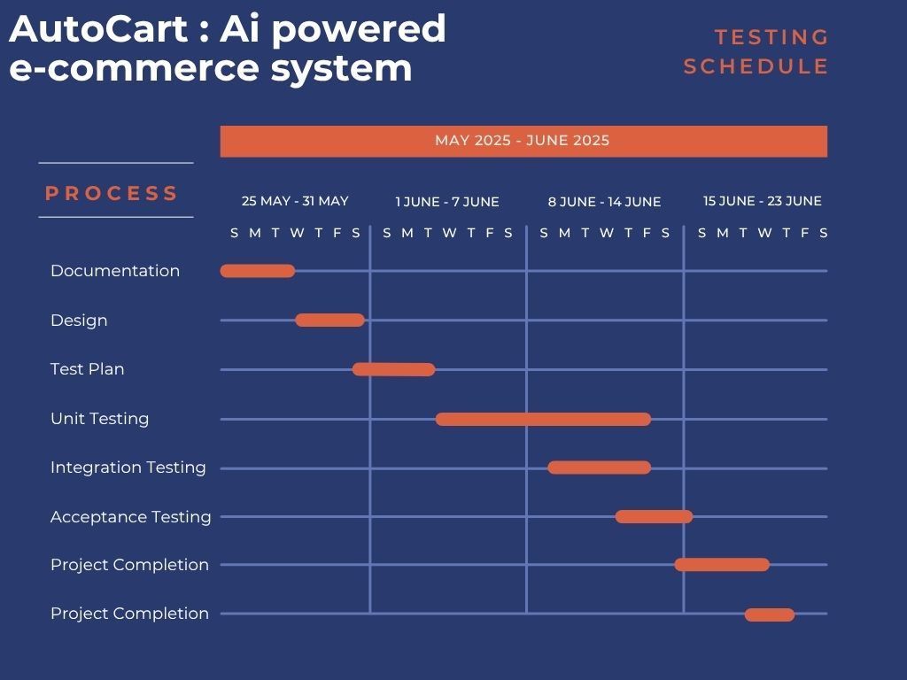

PLANNING RISKS AND CONTINGENCIES
• Limited Availability of Domain Experts: Experts in e-commerce, subscription management, or AI may have restricted availability, potentially delaying validation of predictive models and feature usability. To mitigate this, flexible scheduling and backup consultants will be arranged.
• Data Privacy and Security Risks: Handling customer purchase data and subscription details involves privacy concerns. To address this, strong data encryption, anonymization techniques, and frequent security audits will be implemented.
• Third-Party API Integration Delays: Integration with external payment gateways, delivery services, or AI service providers may face delays. Early API testing, proactive communication with vendors, and use of mock APIs will help minimize impact.
• Limited Testing Resources: Constraints in QA personnel or tools could affect testing timelines. Cross-training team members and prioritizing critical test cases will help optimize resource utilization.
• User Acceptance Testing (UAT) Delays: Delays in customer or stakeholder feedback during UAT could impact project deadlines. A well-defined UAT schedule with regular follow-ups and clear communication channels will be maintained.
• Regulatory and Compliance Challenges: Failure to meet e-commerce and data protection regulations may delay launch. Regular compliance checks and consultations with legal experts will be conducted throughout the project.

APROVALS
Role | Name
Project Sponsor | Shwapno
Project Manager | Farjana Yesmin Opi
Development Team Lead | Md. Abu Towsif
Test Manager | Md Shohanur Rahman Shohan
UI/UX Designer | A. F. M. Rafiul Hassan

